Spectral HRM Toolkit Manual

University of Wisconsin - Madison | 1300 University Ave. 2766 MSC

By: Austin Scholp

Last Updated: August 19, 2021

2021

Table of Contents

Main Menu 2

Open HRM Exam File 2

Pick Event & Select Sensor 2

Run SPARC 2

SPARC Settings 2

Batch SPARC 2

Run NMD 3

Create Figures 3

Compile Data Report 3

Help 3

Event and Sensor Selector 3

Run SPARC 3

Create Figures 3

Batch SPARC 3

# Front Panel

## Main Menu

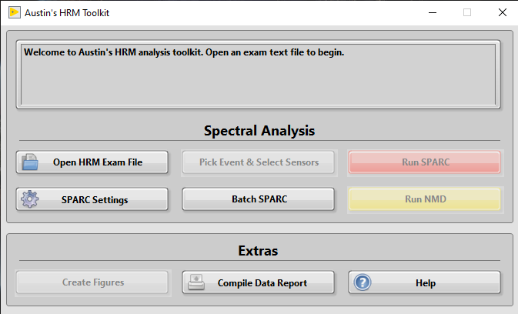The main menu, shown on the right, is the first window shown to the user.

The following sections describe what happens when each of these buttons is pressed.

In the second half of this document, you can find detailed descriptions of the code (Block Diagram).

### Open HRM Exam File

Here, the user is prompted to select an examination file for analysis. Note that only text files will be accepted. Once selected, the program checks if the file has events annotated. The annotation status is added to the main menu message box. If the selected file has annotations, the **Pick Event & Select Sensors** button will be enabled.

If there are no annotations, the Add Annotations button will appear. Clicking this will prompt the user to open the XML file that corresponds to the selected exam file. The annotations will then be added from the XML file to the exam text file.

### Pick Event & Select Sensor/Add Annotations

In this menu, the user selects an event they want to analyze and assigns sensors to each pharyngeal region.

### Run SPARC

* + This will only become active if sensors have been selected in the Pick Event & Select Sensors SubVI.
  + Spectral Arc Length analysis will be carried out on the selected sensors.

### SPARC Settings

* + Opens a menu to allow users to change the SPARC analysis settings (Cut-off frequency, amplitude threshold, and pad level).

### Batch SPARC

* + Will run SPARC analysis on a folder of exam segments. The segments are created for each event that is analyzed during the regular analysis.

### Run NMD

* + Similar to Run SPARC, this will only be active after an event and sensors are selected. Runs Normalized Mean Deviation analysis.

### Create Figures

* + Opens a menu allowing the user to select different figures to create.

### Compile Data Reports

* + Prompts the user to select a folder and compiles the SPARC data from all the smoothness analysis files in that folder.

### Help

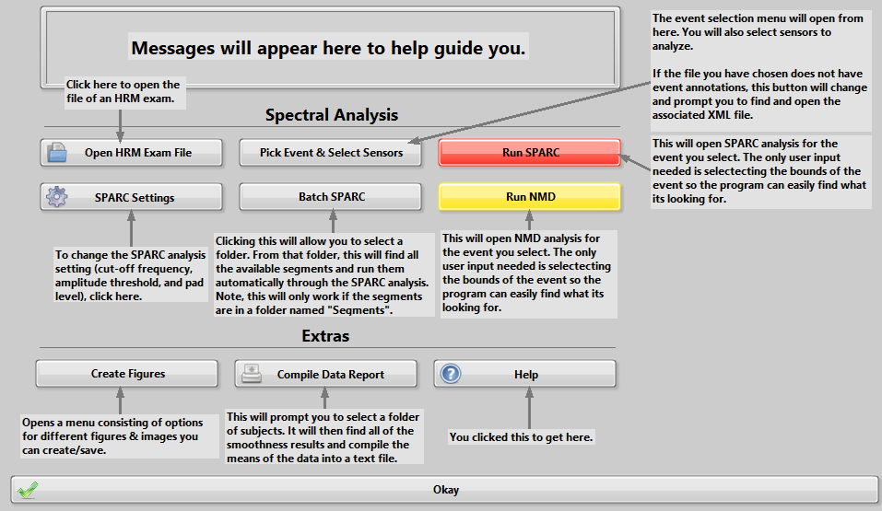This just opens up a window that describes what each button does.